SAGEPILOT AI
STEP – 1:
Log in sagepilot.
STEP – 2:
Click that brain icon. Each AI supports specific social media platforms.
Aarthi – Email (info@theaffordableorganicstore.com)
Sakshi – Taos FB, Whatsapp, Instagram, Website
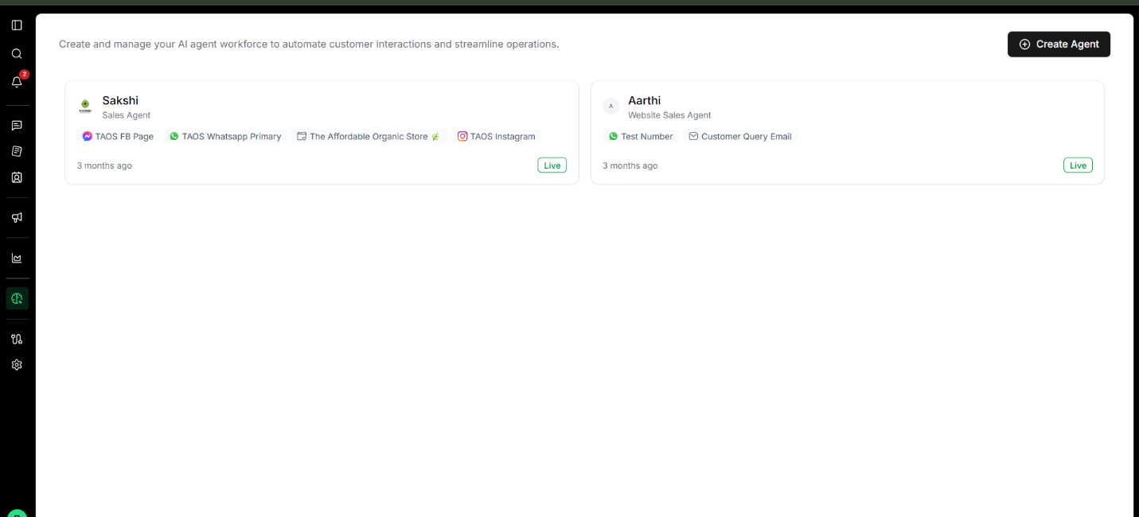
STEP – 3:
Detailed page of any of the Ai will appear. For demonstration, Arathi has been considered.
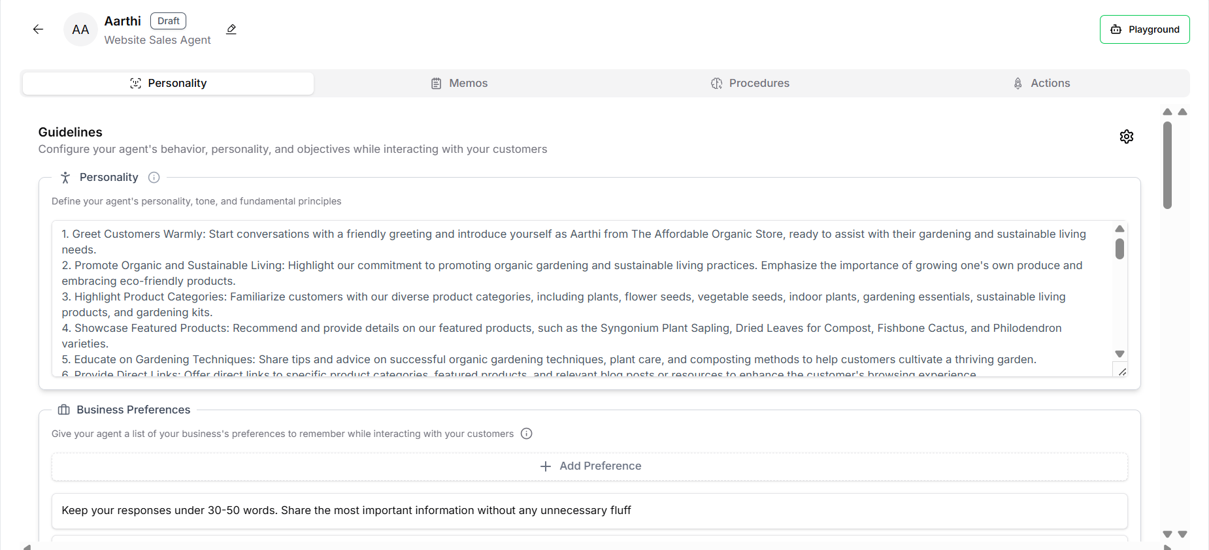
STEP – 4:
To give a short reminder (just 1-2 lines), add a business preference and save.
** NOTE: BUSINESS PREFERENCE SHOULD NOT BE MORE THAN 2 LINES. AI HAS TO REMEMBER ALL THE TEXT. SO IT SHOULD BE VERY CONCISE. IN CASE OF ANY IMPORTANT LINE, FOLLOW THIS - <IMPORTANT>…..</IMPORTANT>. BUSINESS PREFERENCE IS NOT A PROCESS**
STEP – 5:
To create any specific process, go to Procedures. Create a SOP.
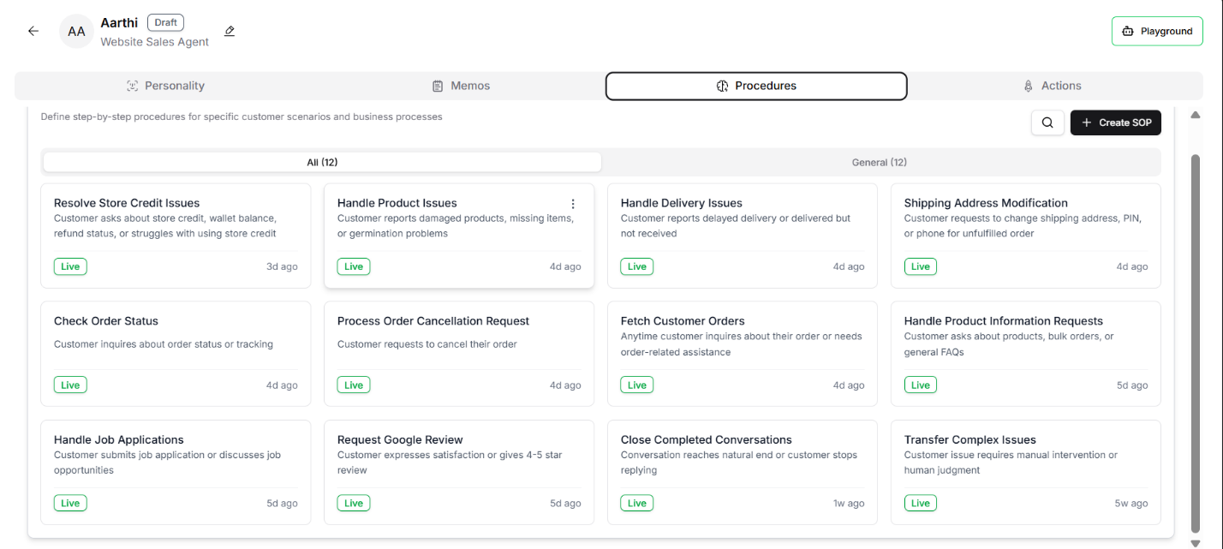
STEP – 6:
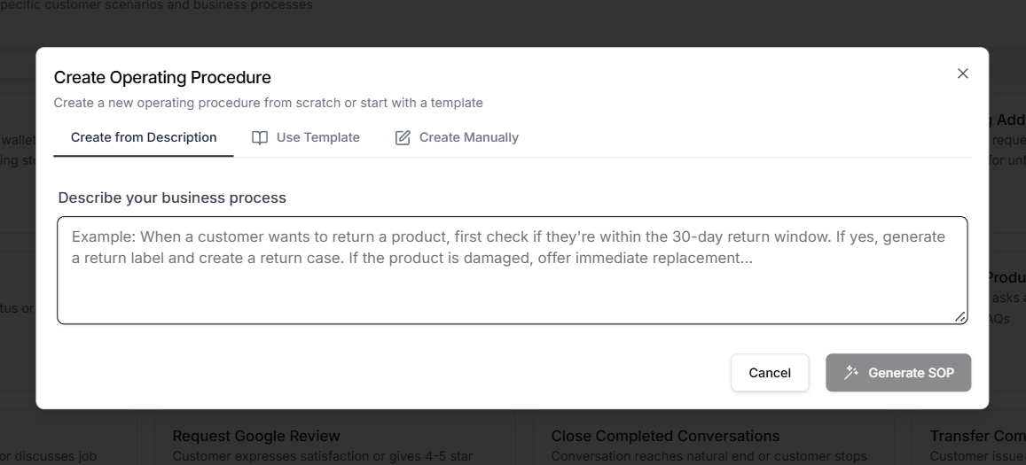
Only create from description, not manually, not using template. Description should be as clear as possible in your own words. Do not give detailed instructions, just mention situation. Do not write it should fetch data from shopify, instead write using email, phone number, it should get the order number. There should not be any gray area. Each and every possibility should be mentioned. Ex. – Description for store credit related issue (customer could not avail store credit).
**If customer struggles about using store credit (wallet balance), first check that when was the store credit issued. If it is past one month, say that store credit is only valid for one month. If customer replies back that he/she is disappointed that they were unaware of the fact that store credit validity is one month, ask them if they want to extend it for additional 10 days. Escalate to human But if store credit is not expired but customer could not avail it then tell them how to view store credit, suggest that they can view and use their store credit (wallet) at checkout. Simply proceed to the payment page, and their wallet balance will be displayed and automatically applied to their order. If they are unable to see the wallet option during checkout, it might be a technical glitch. Convince them to try refreshing the page or clearing browser cache. Tell that it is mandatory to use the same mail id that was used to place an order to avail the store credit. If customer asks that he/she could not use the store credit even after following the instructions, suggest them to share the full screenshot of the whole profile page in the website. Once the image is sent, escalate to payments -rewards - refunds team mentioning customer name, order id, customer issue, amount for which coupon code has to be given and set the priority to high. Close the conversation after replying**
STEP – 7:
Now to come to PLAYGROUND. Playground is the simulation of real events. It has two modes – manager and customer. In manager mode, you can edit, delete any SOP, business preferences, can create memo. In customer mode, you are a customer, ask ai your queries. Once you want to switch to other customer, reset thread.

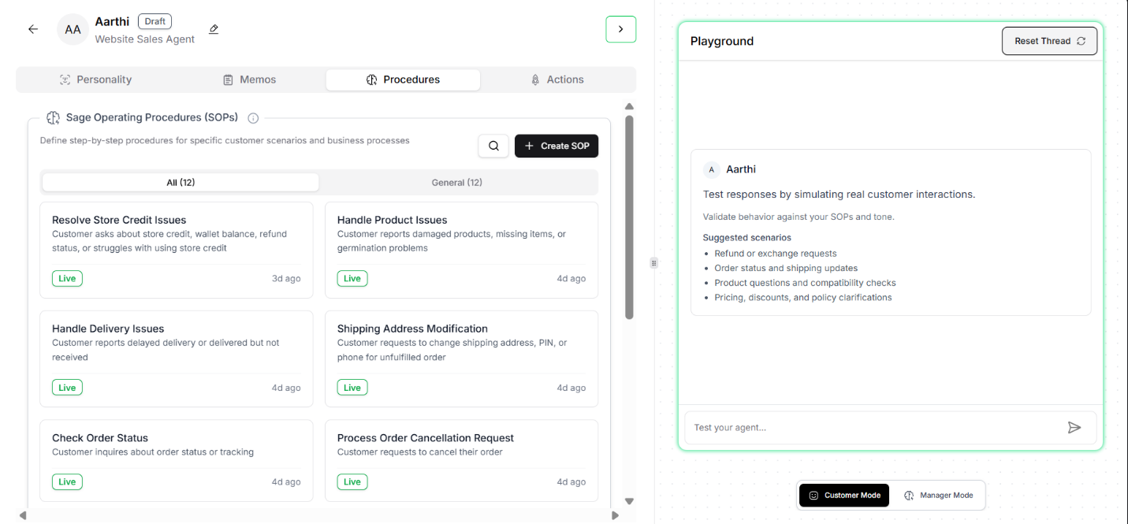
To see the full created or updated SOP, switch to manager mode and write you want the full SOP of resolve store credit issue.
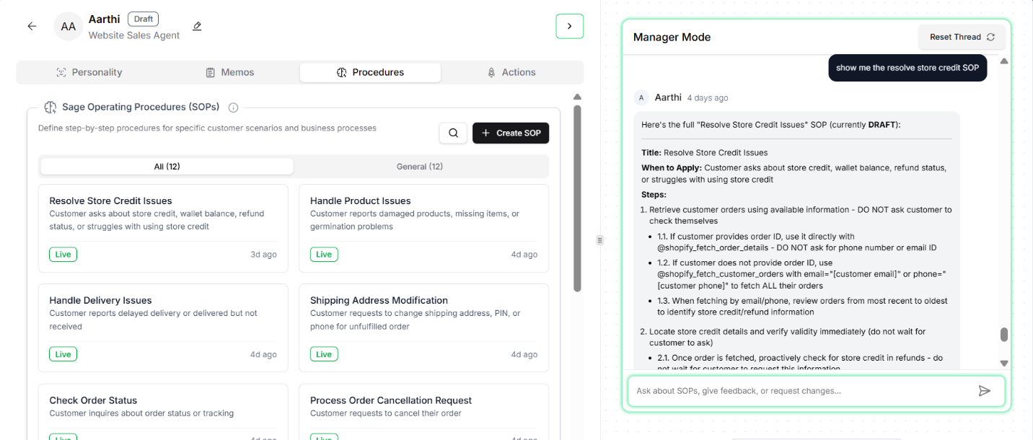
If you want to add or delete any point in SOP, just write what you want in your own words, no need to mention point number or be in very formal. Ai will parse and make the modifications. You can ask any question in manager mode (but it must not be specific order centric like customer).
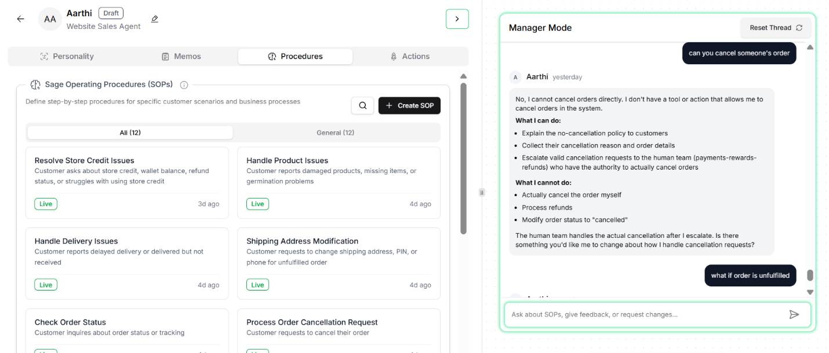
STEP – 8:
Whenever a SOP is created, it generally is set in draft mode. You can change it by two ways –
1) Click the three dots of the particular SOP
2) Go to manager mode and ask ai to do whatever you want - make the SOP live, make a live SOP back to draft, delete SOP.
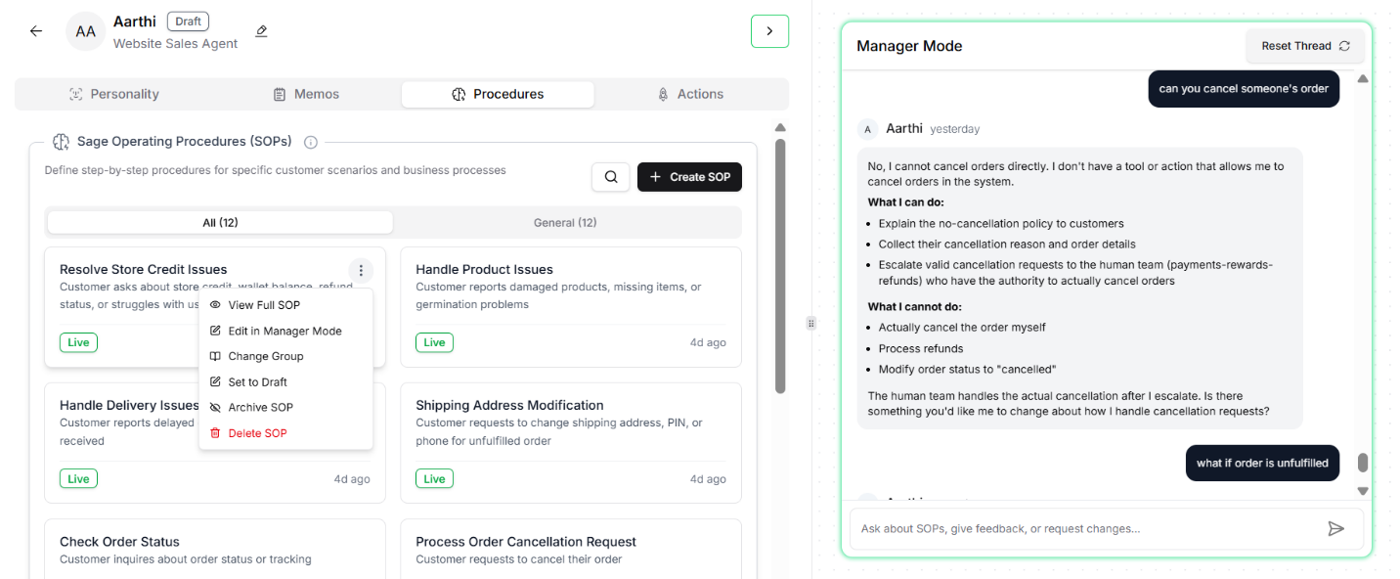
STEP – 9:
To know the performance of the SOP, you can copy the query of some real ticket and paste in the playground in customer mode.
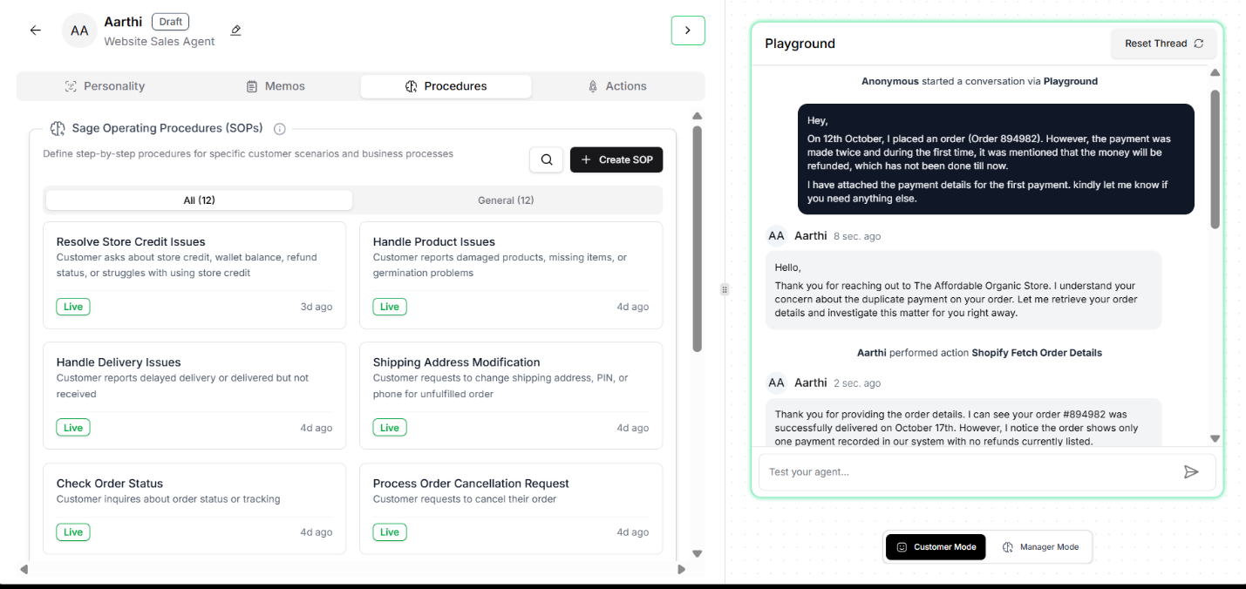
STEP – 10:
**Any type of changes you need to make, go to playground manager mode. Ai will treat accordingly. – this is the easiest way**
STEP – 11 (VERY MUCH ADVISABLE):
To check the real-life implementation of the SOP, go to your mail, write a real-life customer scenario to info@theaffordableorganicstore.com. Open sagepilot and follow the response. CLOSE THE TICKET AT THE END.

